Attachment A

Superintendent’s Memo #076-22

April 8, 2022

SNPWeb Community Eligibility Provision Site Eligibility Report Checklist 2022
The report for all schools/sites in the school food authority (SFA) is due in SNPWeb by Friday, April 15, 2022, at 5:00 p.m.
Listen to the e-learning module for the April 1 Identified Student Percentage (ISP) report on the Virginia Department of Education, Office of School Nutrition Programs (VDOE-SNP) Rise.com e-learning portal.
Information needed to complete the report:
For the number of identified students (free only by direct certification (DC) and categorical eligibility):
  - Work with your software vendor to create an Excel spreadsheet of the free DC and categorically eligible identified students as of April 1, 2022, from your local eligibility software.
    - The report of identified students by school must include:
      - students’ names;
      - students’ free eligibility without application type (DC SNAP, DC TANF, DC Medicaid Free, homeless, foster care, etc.);
      - eligibility date; and
      - the school name or number.
    - Students determined free eligible by an application, with income or case number, and students determined reduced-price eligible by any means, including Medicaid DC reduced-price, must not be included in the identified students report.
  - Important: SFAs are required to maintain documentation to support the number of identified students reported as of April 1, 2022.
    - Required documentation includes a complete electronic sortable file (such as an Excel spreadsheet) listing of all DC/categorically eligible free students (including name, status, and date) that supports the number reported in the SNPWeb CEP Site Eligibility Report.
      - Acceptable documentation does not include a paper or PDF report, or a report with only the number of DC/categorically eligible free students as of April 1.
For the school enrollment (membership) for school nutrition programs:
  - Use the school/site Principal’s Monthly Report by school as of April 1, 2022, to determine the school enrollment (membership).
    - The terms membership and enrollment are used interchangeably by the USDA. For this report, include only students who would have access to at least one meal at the school.
    - The Principal’s Monthly Report membership number is usually the number that reflects currently active students.
  - Include enrollment/membership data by school for programs not reported in the Principal’s Monthly Report, such as Head Start, Virginia Pre-school Initiative (VPI), and alternative education programs, if applicable, and if students in these programs are eligible to participate in the National School Lunch Program.
  - Maintain reports on file in the LEA as documentation of the enrollment reported.
Determine the total number of identified students and the total enrollment/membership.
Log into SSWS and the SNPWeb software.
From the main screen, select the Applications tab. Scroll down the item list to Community Eligibility Provision (CEP) and select it.
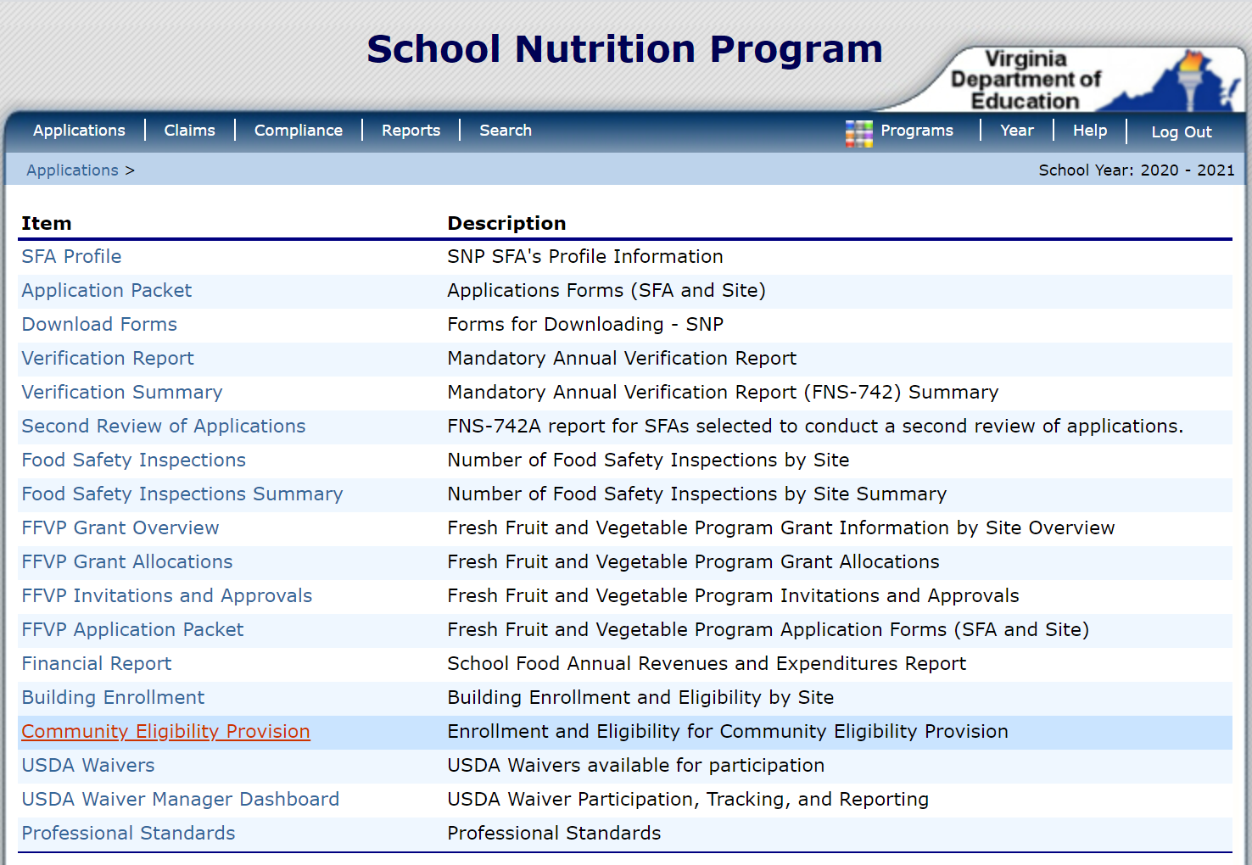

View the CEP Site List screen. Under Action, select Add for the 2021–2022 school year.
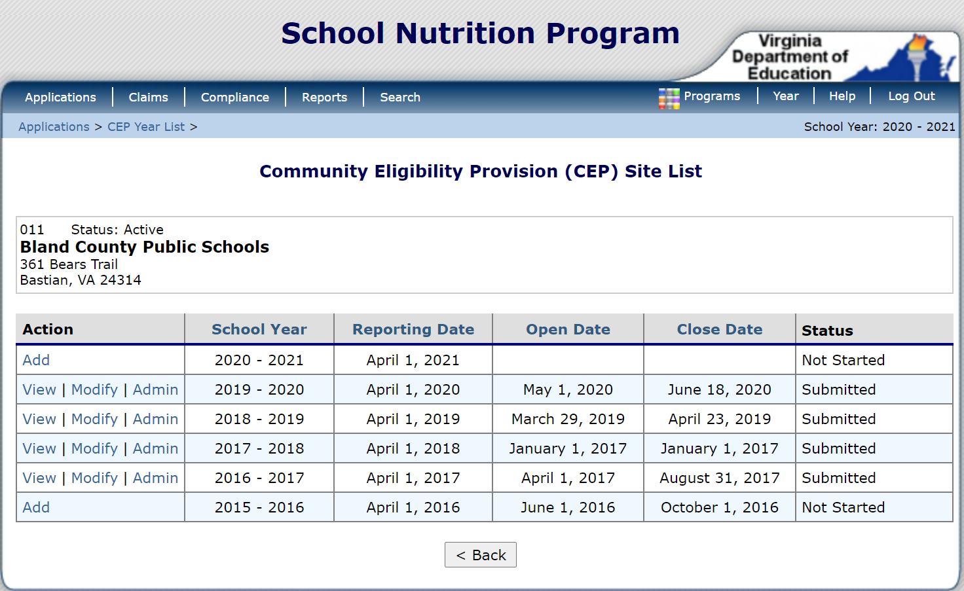
View the complete list of schools/sites for the SFA. Schools/sites are in site number order using the official name from the VDOE database.
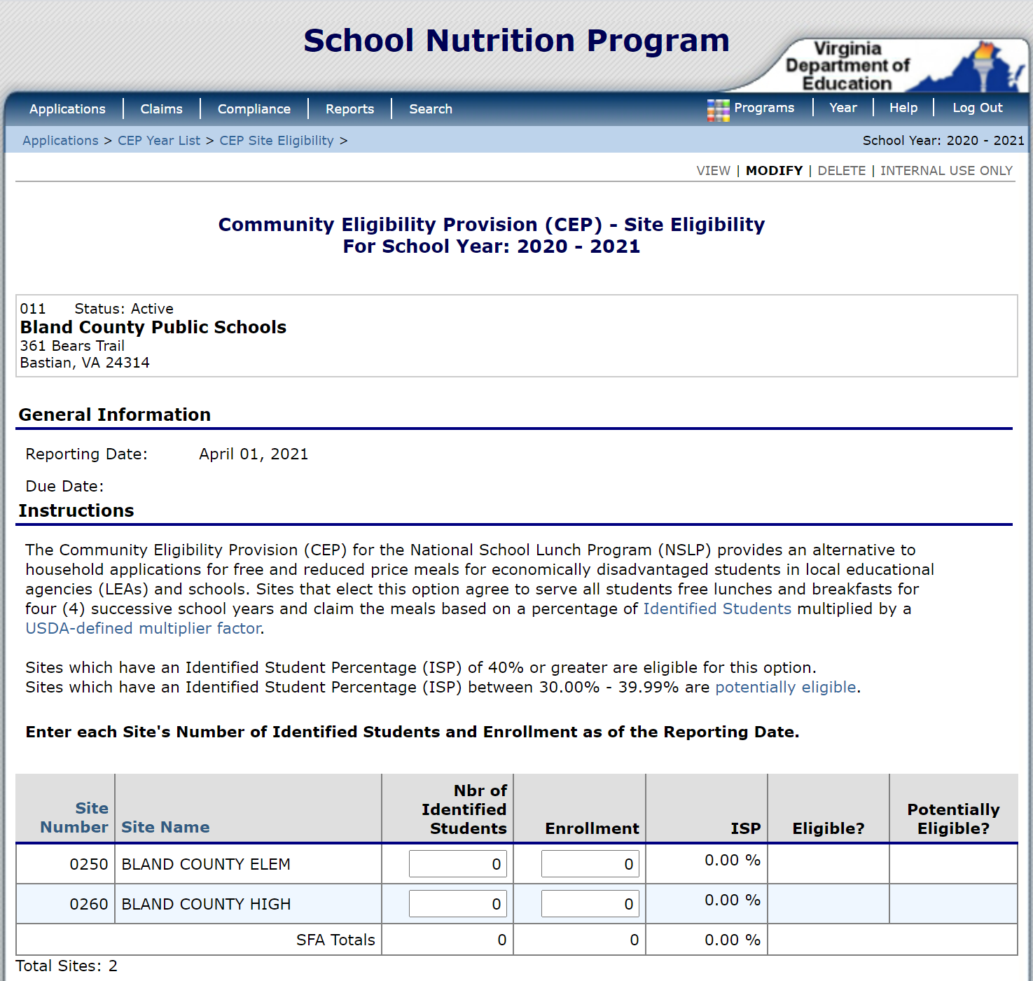
There are two fields open for data entry: Number of Identified Students and Enrollment. Enter the number of identified students (Free by DC or categorically eligible free from explanation above) and the total SNP enrollment for each school/site. SNPWeb will calculate the ISP and Eligible/Potentially Eligible columns.
Review the data. Click the red Save button at the bottom to trigger the SNPWeb edits.
If error messages appear at the top of the screen, review and edit data. Select Save when finished.
To return to the report after saving, select Modify from the CEP Site List screen.
When data is complete, with no error messages, select Save to submit. If there are no errors, the Save Confirmation screen will appear. Select Finish to confirm and submit the report.
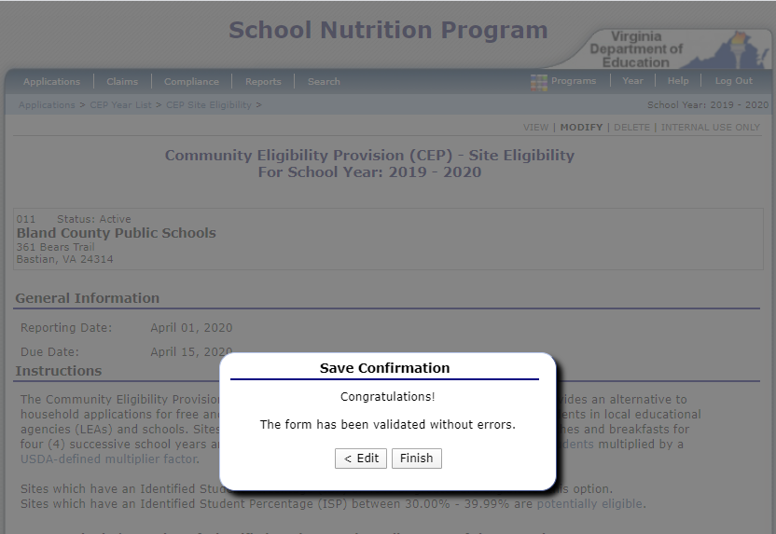
The report is complete and submitted when the status to the right displays Submitted.
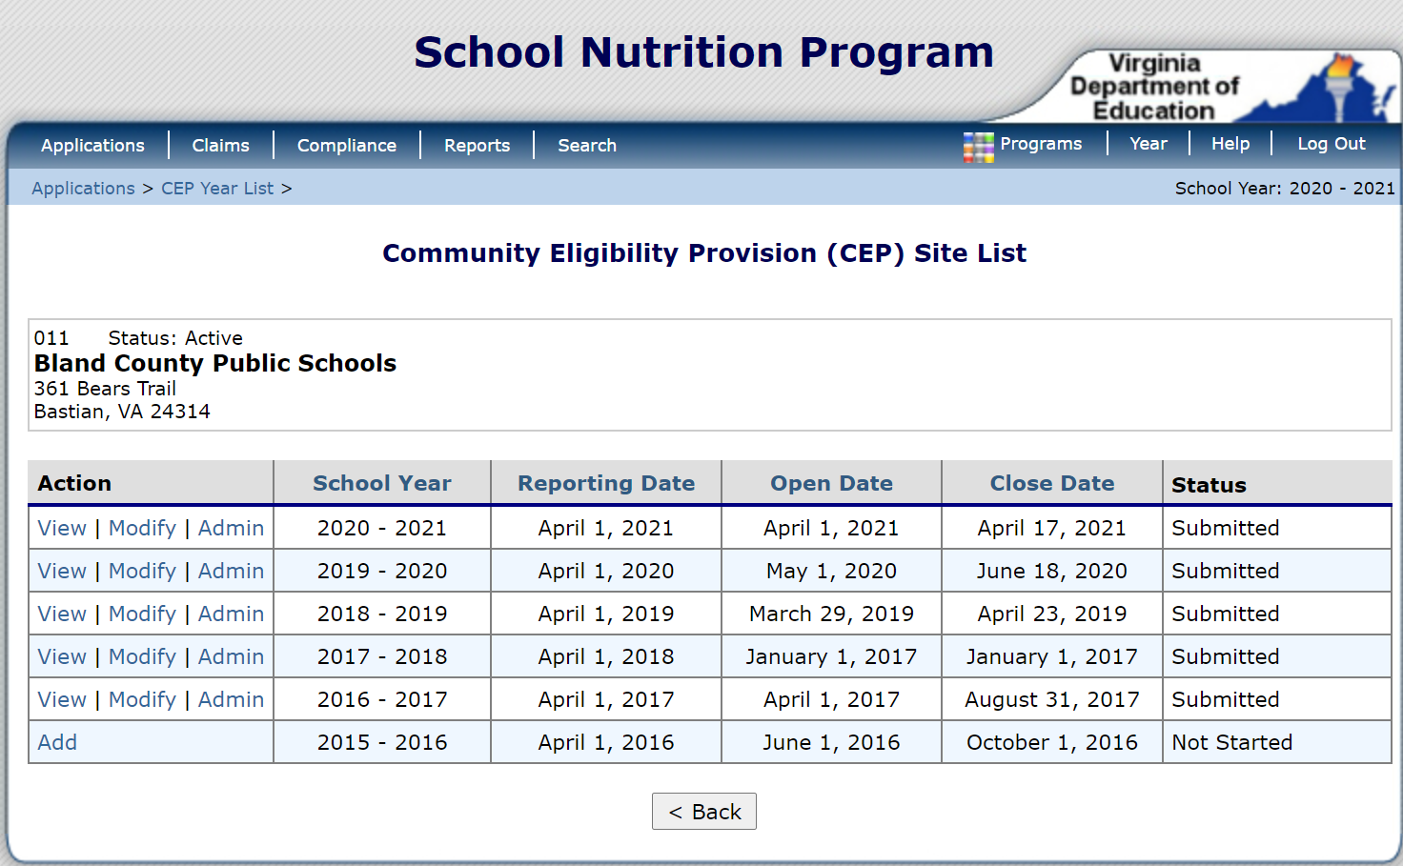
VDOE-SNP staff will review the report and contact the LEA if edits are needed. When the report has been approved, the status to the right will be updated to Approved.

