Virginia Department of Education

Individuals with Disabilities Education Act (IDEA)
Proportionate Set-Aside Guidance Document

Overview
Each local educational agency (LEA) must spend a proportionate amount of its Sections 611 and 619 allocations on providing special education and related services (including direct services) to home-schooled or parentally-placed private school children with disabilities. Section 300.133 of the Individuals with Disabilities Education Act (IDEA) specifies a formula that an LEA is required to use to determine the proportionate amount the LEA is to make available or spend to meet the requirements
of § 300.132(a).

§ 300.132 (a)
“… To the extent consistent with the number and location of children with disabilities who are enrolled by their parents in private, including religious, elementary schools and secondary schools located in the school district served by the LEA, provision is made for the participation of those children in the program assisted or carried out under Part B of the Act by providing them with special education and related services, including direct services determined in accordance with § 300.137….”
The Virginia Department of Education’s (VDOE’s) Department of Special Education and Specialized Populations will continue to use the web-based application to collect school divisions’ proportionate share calculations for the fiscal year 2025-2026 grant period. This application will be made available through the VDOE’s Single Sign-on for Web Systems (SSWS) portal.

Background
This information is taken directly from the IDEA federal regulations § 300.133 and Appendix B to Part 300 – Proportionate Share Calculation. Each LEA must expend, during the grant period, on the provision of special education and related services for the parentally-placed private school children with disabilities enrolled in private elementary schools and secondary schools located in the LEA, an amount that is equal to:
- A proportionate share of the LEA’s sub-grant under Section 611(f) of the Act for children with disabilities aged 3 through 21. This is an amount that is the same proportion of the LEA’s total sub-grant under Section 611(f) of the Act as the number of parentally-placed private school children with disabilities aged 3 through 21 enrolled in private elementary schools and secondary schools located in the LEA is to the total number of children with disabilities enrolled in public and private elementary schools and secondary schools located in the LEA aged 3 through 21.
- A proportionate share of the LEA’s sub-grant under Section 619(g) of the Act for children with disabilities aged three (3) through five (5). This is an amount that is the same proportion of the LEA’s total sub-grant under Section 619(g) of the Act as the total number of parentally-placed private school children with disabilities aged three through five enrolled in private elementary schools located in the LEA is to the total number of children with disabilities enrolled in public and private elementary schools located in the LEA aged three (3) through five (5).
- As described in Paragraph 2 of this section, children aged three (3) through five (5) are considered to be parentally-placed private school children with disabilities enrolled by their parents in private, including religious, elementary schools if they are enrolled in a private school that meets the definition of elementary school.
- If an LEA has not expended for equitable services all of the funds described in Paragraphs 1 and 2 by the end of the fiscal year for which it was appropriated, the LEA must obligate the remaining funds for special education and related services (including direct services) to parentally-placed private school children with disabilities during the carry-over period of one additional year.
- In calculating the proportionate amount of the IDEA Part B funds that must be expended, the LEA, after a timely and meaningful consultation with a representative, must conduct a thorough and complete child find process to determine the number of parentally-placed children with disabilities attending a private school located in the district. To determine the number of parentally-placed students with disabilities attending private schools, the LEA must conduct an annual count and ensure that the count is done on any date between October 1 and December 1, inclusive, of each year. The count must be used to determine the proportionate share the LEA must spend in providing education to students with disabilities parentally-placed in private schools in the next subsequent fiscal year.
- State and local funds may supplement and, in no case, supplant the proportionate amount of federal funds required to be expended for parentally-placed students with disabilities under
this part.
- The proportionate share of IDEA funds must be determined before designating funds for any Coordinated Early Intervening Services (CEIS), as specified in § 300.226 of the
IDEA regulations.
- Dollar amounts must be calculated for both Sections 611 and 619 funds. The combined amounts for ages 3 through 5 and ages 3 through 21 represent the total amount that must be set-aside. Effective FY2023, the total required amount can no longer be spent out of Section 611 funds. A system enhancement has been made to calculate the 611 and 619 proportionate set-aside amounts separately for each LEA.
The following image outlines how the proportionate share is calculated.
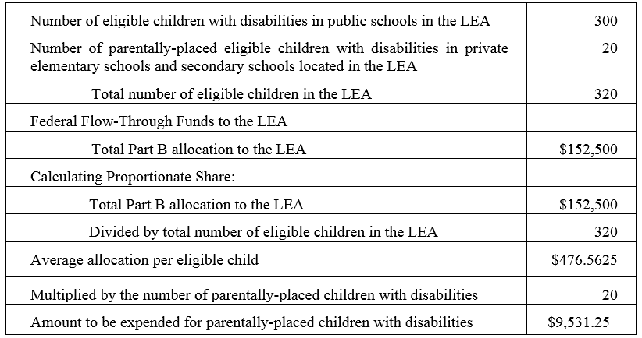

Steps in Using the Proportionate Set-Aside (Speced-PSA) Application

General Information
The process for completing the VDOE’s Proportionate Set-Aside (Speced-PSA) web-based application is provided to guide users reviewing information and to determine the proportionate share of the LEA’s total Part B sub-grants in providing services to home-schooled or parentally-placed private school children aged 3 through 21. Please note that Virginia Regulations allow for the inclusion of two-year-olds. As such, two-year-olds may be included if the two-year-old is enrolled by their parent in a private elementary school or homeschooled. The calculated amount will be the school division’s basis when requesting reimbursement through the VDOE’s Online Management of Education Grant Awards (OMEGA) system.
A system enhancement in 2023-2024 was made to calculate the 611 and 619 proportionate set-aside amounts separately for each LEA. This update changed the layout of the worksheet and reports to have three columns which includes a total column. The 2024-2025 enhancement updated all of the data fields to be prepopulated. The LEA will not have to input any of the data fields.

Proportionate share costs are not limited to direct services but can include consultative services, equipment, or materials for eligible home-schooled or parentally-placed students with disabilities, or training for private school teachers and other private school personnel. The school division must maintain title to property or items purchased and must ensure that equipment or supplies placed in private schools are only used for equitable service provision.

The LEAs are prohibited from using the set-aside amount for administrative costs, the costs of child find, and the evaluation process of home-schooled or parentally-placed private school students.

Accessing and Using the Application
The application can be accessed through the VDOE’s SSWS portal. If the Speced-PSA Application is not available within the user’s menu page, the user must contact the school division’s local SSWS Administrator to obtain access rights. A login ID and password will be provided by the local SSWS Administrator once access rights are granted. The following link can be used to access the
VDOE home page.
- Figure 1 shows how to access the SSWS portal. Click the “SSWS Login” located at the top middle of VDOE’s home page.
Figure 1
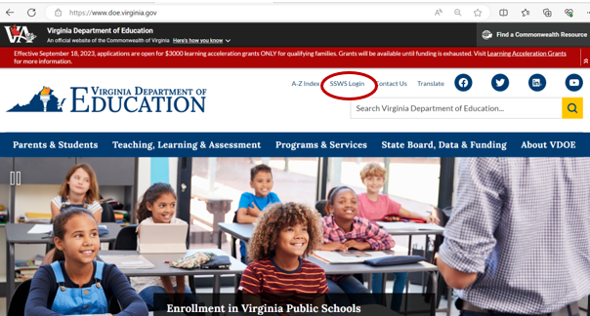
- Figure 2 displays the SSWS login screen. The person responsible for reviewing the information will need a login ID and password to access the web-based application. The local SSWS Administrator should be contacted to obtain the SSWS login ID and password.
Figure 2

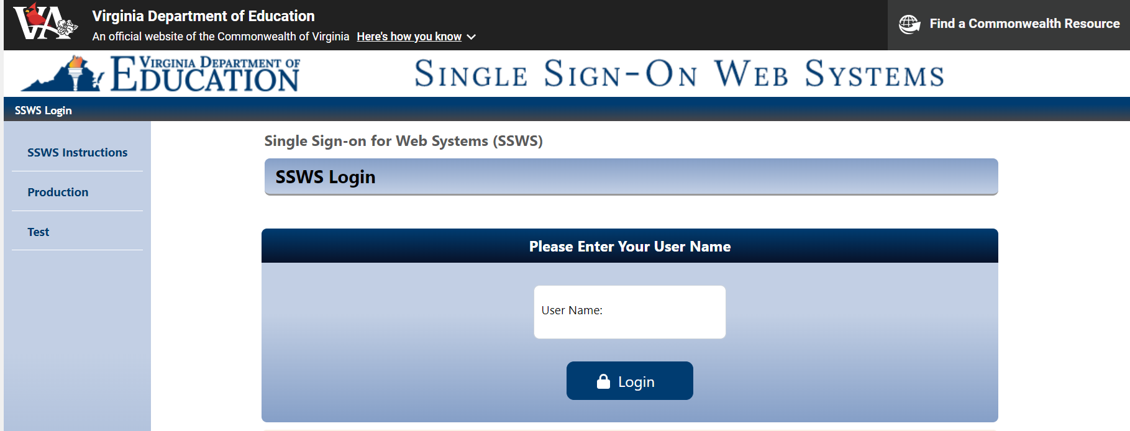

- Figure 3 displays the password screen. The user must have the SSWS login ID and password to access the web-based application.

Figure 3

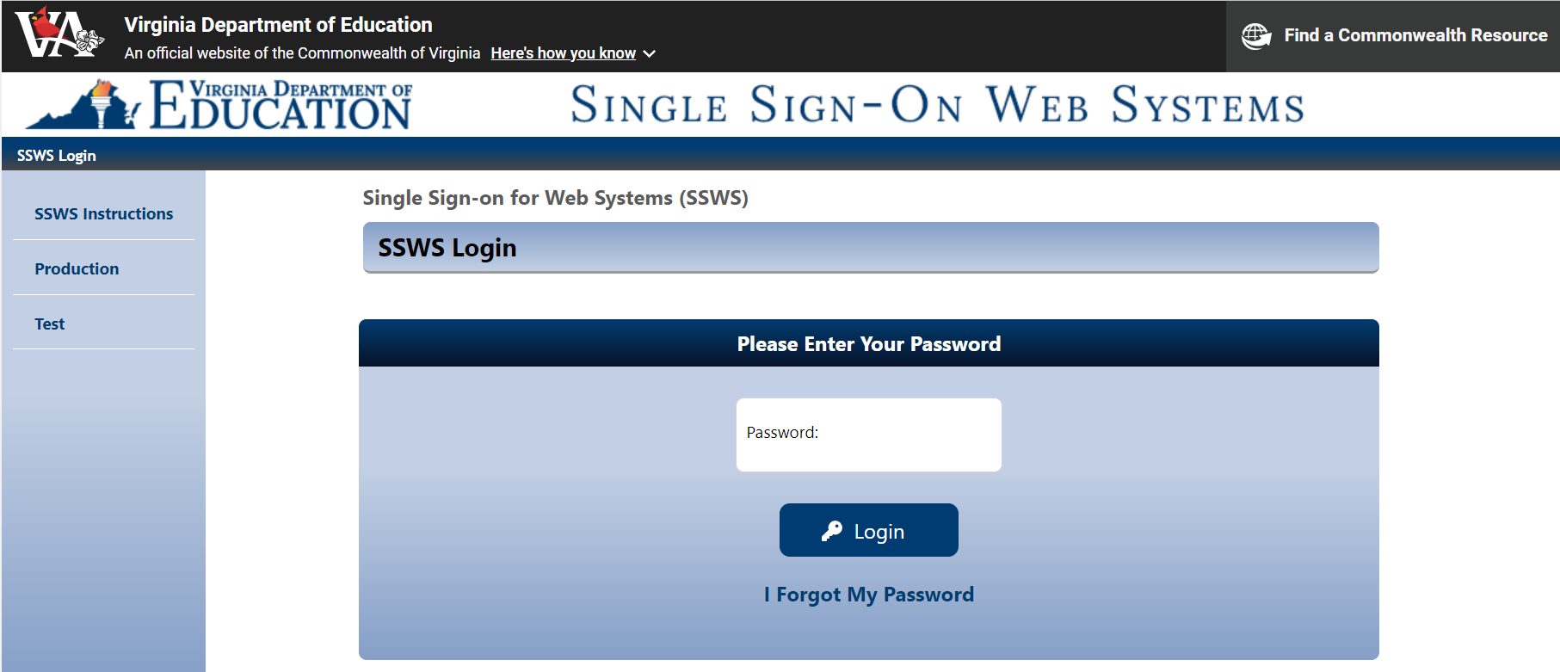
- After a successful login, the application menu will display as shown in Figure 4. Select “Special Education Proportionate Set-Aside (Speced-PSA)” from the applications listed in the user’s menu. If it is not available in the user’s menu, the user must contact their local SSWS Administrator to obtain full access rights.
Figure 4
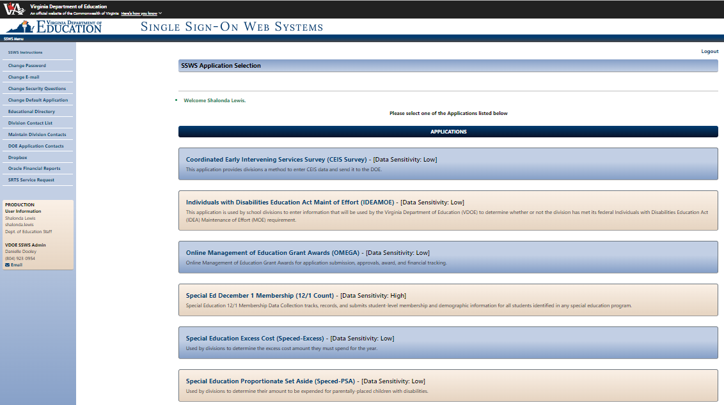
- Figure 5 displays an example of the screen after the Speced-PSA Application is clicked. The screen will display the closing date as 11/17/2025 for the 2025-2026 school year. The collection window will close at 11:59 p.m. on 11/17/25 (i.e., prior to midnight on 11/18/25). The collection window must be open for the current fiscal year in order to submit information and for the data to be saved and processed. There are two (2) available options on the upper left side of the page for the user to select.
Worksheet – Selecting this option will display the screen where users can view the information to determine the division’s proportionate share. Line details are described in subsequent pages.
Reports – Selecting this option will display the screen where the Verification Report can be viewed or printed. Verification Reports are approved in electronic form. (Refer to pages 10-11 for additional information).
Figure 5

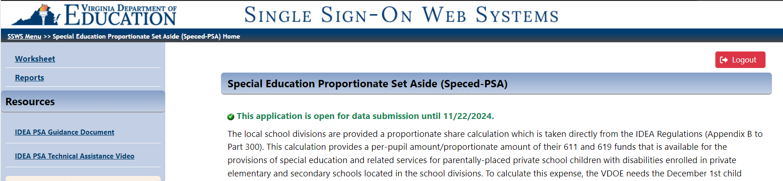

- Figure 6 shows what is displayed after selecting the “Worksheet” option from the menu on the upper left side of the screen. This is the screen where the majority of the data is pre-populated to calculate the division’s proportionate share. The worksheet is composed of Lines 1 to 10. A recent enhancement has separated the 611 and 619 calculations by creating three columns, which include a total column. All lines for sections 611 and 619 are auto-generated and auto-calculated. Refrain from using the “back” button when navigating the application, as it will cause the application to function incorrectly. Instead, use the options available at the top of the screen. The sample print screen in Figure 6 displays all lines auto-populated for sections 611 and 619. The user must verify information related to the number of home-schooled or parentally-placed students found eligible during the child find process, but not receiving services during the school year. The number displayed in Lines 1 through 3 is reported in the December 1 Child Count. In addition, amounts in Lines 5 and 8 are pre-populated from Omega, and Lines 4, 6, 7, 9, and 10 are auto-calculated. Refer to instructions and illustrations starting on page 7.
- Divisions should be mindful when reviewing and submitting for the PSA data collection that the child count data is duplicated where age categories are collected in each section. Section 611 includes ages 3 to 21, and section 619 includes ages 3 to 5. (Note: age 2 may be included, as applicable).
Figure 6
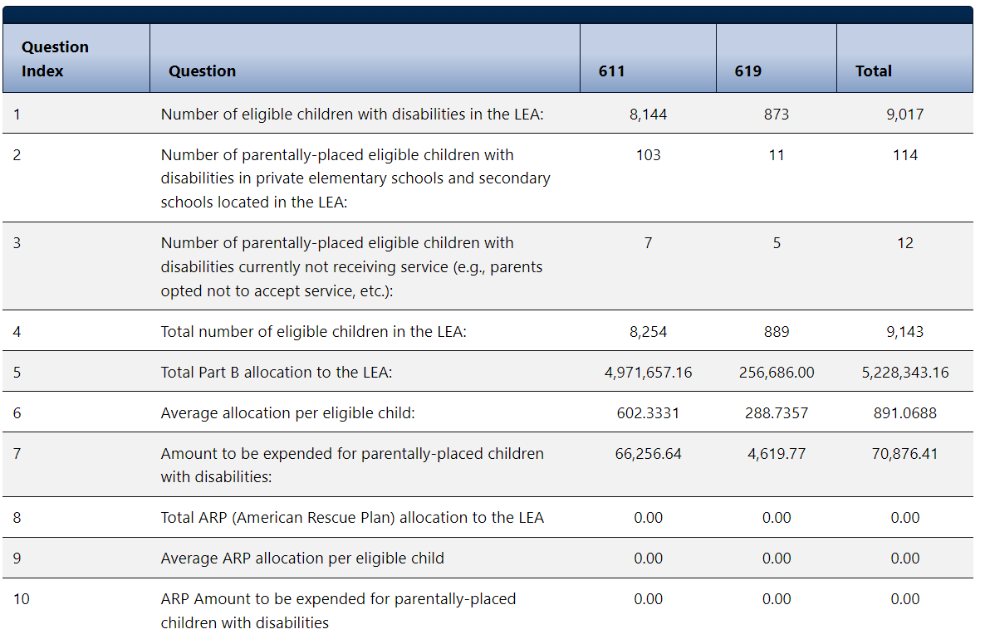
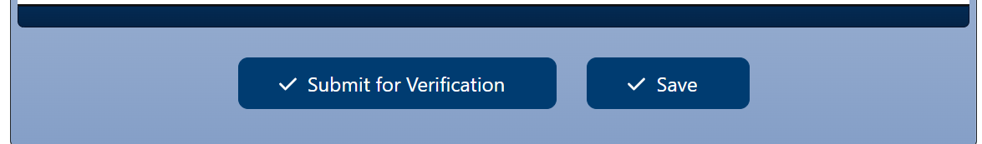

The following example is for illustration purposes only:
There are 8,144 eligible section 611 children with disabilities enrolled in the LEA, and 103 are eligible parentally-placed children with disabilities currently enrolled and being served in private elementary schools and secondary schools located in the LEA. The division has seven identified students as eligible parentally-placed children with disabilities that are not currently receiving services. The total number of eligible public and private school children with disabilities is 8,254. Note: Proportionate share for parentally-placed private school children is based on total children eligible, not children served for sections 611 and 619. The LEA receives a total of $4,971,657.16 in Federal flow-through funds for IDEA regular 611. Therefore, the LEA must set-aside $66,256.64 of special education or related services funds to the group of parentally-placed private school children with disabilities enrolled in private elementary schools and secondary schools located in the LEA for 611.
An additional column has been added to separate section 619. For section 619, there are 873 eligible children with disabilities enrolled in the LEA, and 11 are eligible parentally-placed children with disabilities currently enrolled and being served in private elementary schools and secondary schools located in the LEA. The division has five identified students as eligible parentally-placed children with disabilities who are not currently receiving services. The total number of eligible public and private school children with disabilities is 889. The LEA receives a total of $256,686 in Federal flow-through funds for IDEA regular 619. Therefore, the LEA must set-aside $4,619.77 for section 619
The last three lines, 8, 9, and 10, are not relevant to the 2025-2026 school year, and no data should populate for sections 611 or 619.
- An illustration of the above example is shown in Figure 7, and the details of questions 1 to 10 are described on pages 8 and 9.
Figure 7

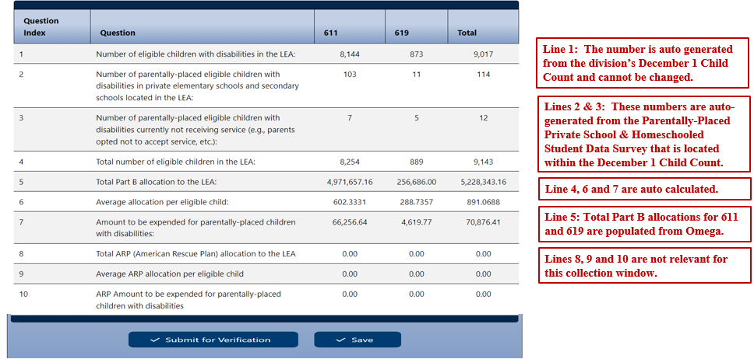

- Line 1 – The number of eligible students will be automatically populated for 611 and 619 from the system using the auto-generated December 1 Child Count submission when the collection window is open. In the example in Figure 7, Line 1 indicates 8,144 for 611 and 873 students for 619. This number represents students who are receiving special education and related services within the division. However, it excludes private school and home-schooled children who are eligible and served. Eligible students are students who have been evaluated and determined eligible for special education and related services by the division. Note: The number of eligible students cannot be changed since it is auto-generated from the division’s December 1, 2024, child count submission, duly certified by the division’s superintendent and reported to the U.S. Department of Education (USED).
- Line 2 – The number of home-schooled or parentally-placed eligible students will be populated from the system using the auto-generated December 1 Child Count. In the example in Figure 7, Line 2 indicates 103 for 611 and 11 students for 619. This represents the number of children with disabilities parentally-placed in private school or home-schooled in the LEA after conducting a thorough and complete child find process and ensuring that the count was performed between December 2 of the preceding year to December 1 of the current year (e.g., December 2, 2023 - December 1, 2024) and reported in the December 1, 2024, child count report. Note: The number of home-schooled or parentally-placed eligible children with disabilities in private schools cannot be changed since it is auto-generated from the division’s December 1, 2024, child count submission, duly certified by the division’s superintendent and reported to the USED. Divisions serving parentally-placed or home-schooled students who were not reported in their December 1 Child Count report must contact the VDOE for additional guidance on reporting these students.
- Line 3 – The number of home-schooled or parentally-placed students identified during the child find process as being eligible for services (i.e., December 1, 2024) but are not receiving services due to various reasons (e.g., parent has opted not to accept services). The data is populated from the system using auto-generated data previously submitted with the division’s December 1 child count for sections 611 and 619. The child count must be between December 2 of the preceding year to December 1 of the current year. The division is required to set-aside a proportionate amount for the students’ future use. Figure 7 illustrates seven students for section 611 and five for section 619 in Line 3.
- Line 4 – Auto-generated and represents the total number of students with disabilities in public and private schools and home-schooled. Based on the illustration, Line 4 shows a total of 8,254 students for section 611 and 889 students for section 619 (sum of Lines 1, 2, and 3). Note: The line total may be more than the actual December 1 Child Count if there are students reported in Line 3, since students ages 3 to 5 are included under 611 and 619 or age 2 as applicable.
- Line 5 – The total FFY 2025-2026 Part B 611 and 619 allocations of the division will be automatically populated from the Online Management of Education Grant Awards (OMEGA). In Figure 7, Line 5 indicates $4,971,657.16 for 611 and $256,686 for 619 as the actual total Part B funds received.
- Line 6 – Auto-generated average allocation per eligible child. This amount represents the proportionate share of the divisions per eligible child. In the illustration in Figure 7, Line 6 shows $602.3331 for section 611 and $288.7357 for section 619 (Line 5 divided by Line 4).
- Line 7 – Auto-generated amount to be expended for home-schooled or parentally-placed children with disabilities. This amount represents the total amount of regular IDEA Part B federal funds that must be set-aside for home-schooled or parentally-placed children with disabilities. In the illustration of Figure 7, Line 7 shows a total amount of $66,256.64 for section 611 and $4,619.77 for section 619 (Line 6 multiplied by the sum of Lines 2 and 3). Note: Any funds not spent or obligated by June 30, 2026, for special education and related services (including direct services) must be carried forward for one additional year (i.e., July 1, 2026 - June 30, 2027). Any unspent funds after the one-year carry-over period can be used on other special education and related services (refer to page 13). State and local funds may supplement and NOT supplant the proportionate amount of Federal funds required to be expended for parentally-placed students with disabilities. Effective fiscal year 2023, divisions are no longer allowed to spend the total required amount out of section 611 funds.
- Lines 8, 9, and 10 – These lines are not relevant for the 2025-2026 school year.
If the user is ready to submit the worksheet, first click the “Save” button, then click the “Submit for Verification” button. If the user is not ready to submit, click the “Save” button, and the worksheet will remain open for review. Once the worksheet is submitted, the collection window will automatically lock, and the application will notify the superintendent to review and approve the submission. If a concern or issue arises after the worksheet is submitted, but before approval, the user must notify their superintendent to disapprove the submission to unlock the collection window. If a concern or issue arises after the submission is already approved, the user must contact VDOE to reopen the collection window. NOTE: If, for some reason, the window needs to be reopened after the due date but before approval, the user must contact VDOE via email to reopen the collection window.

- Figure 8 displays an example of the screen after the worksheet is submitted. The superintendents or designees are required to sign the certification reports in electronic form prior to the due date of 11/17/25 using the Superintendent Data Collection Approvals (SDCA) Application (refer to Figures 9 and 10).
Figure 8

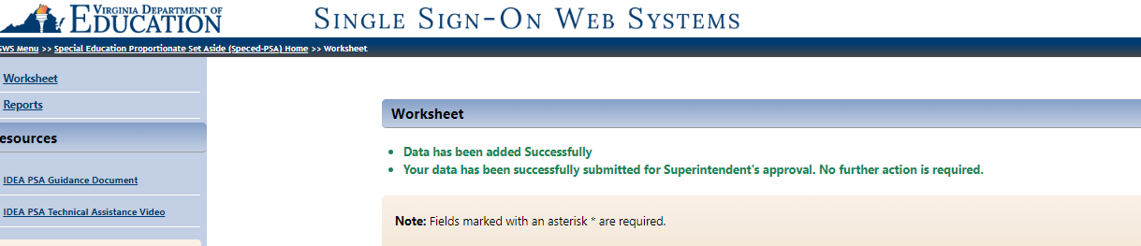

- Figure 9 illustrates the screen for SDCA after the superintendent or designee has successfully logged in to SSWS. A user’s ID and password are required to access the SDCA which can be obtained through the division’s local SSWS Administrator if the application is not available in the superintendent’s or designee’s menu.
Figure 9
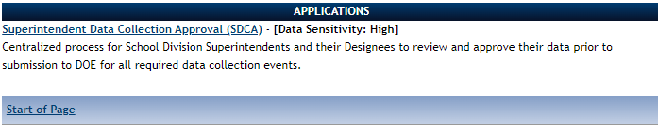

- Figure 10 displays an example of the screen after the SDCA menu is clicked. The superintendent or designee must select the “Proportionate Set-Aside Verification Report” in the list of report names for approval to access the verification report. (The due date on the 2025-2026 verification report should display as 11/17/2025. The approval must be made prior to the collection window close date of 11/17/2025 at 11:59 p.m.)
Figure 10
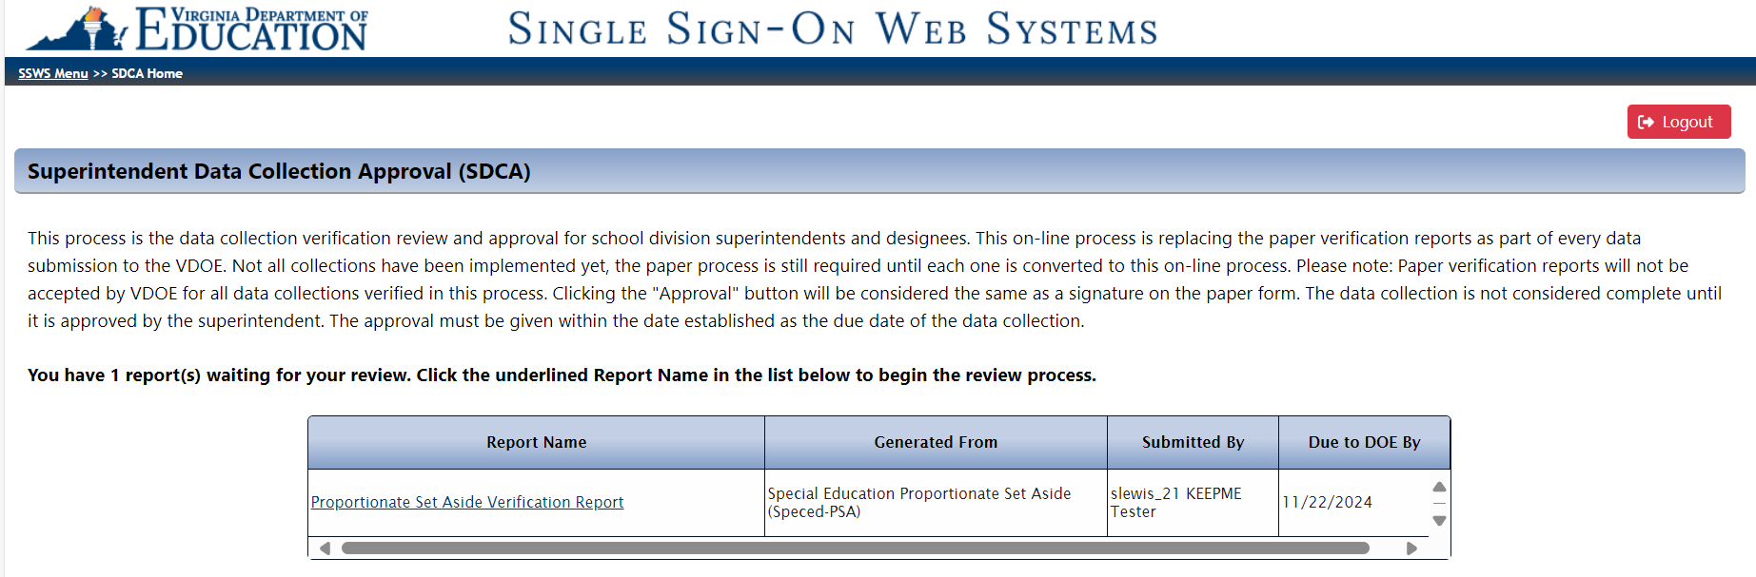

- Figure 11 displays an example of the PSA Verification Report with two functions added: the Approve” and “Disapprove” buttons. The superintendent or designee must choose one function after reviewing the submitted data to proceed to the next screen. If the “Approve” function is selected, the submission is completed, and the collection window will close (refer to Figure 12). If the “Disapprove” function is selected, the collection window is reopened, and resubmission is required (refer to Figure 13). A data note is required for disapproved submissions.
Figure 11

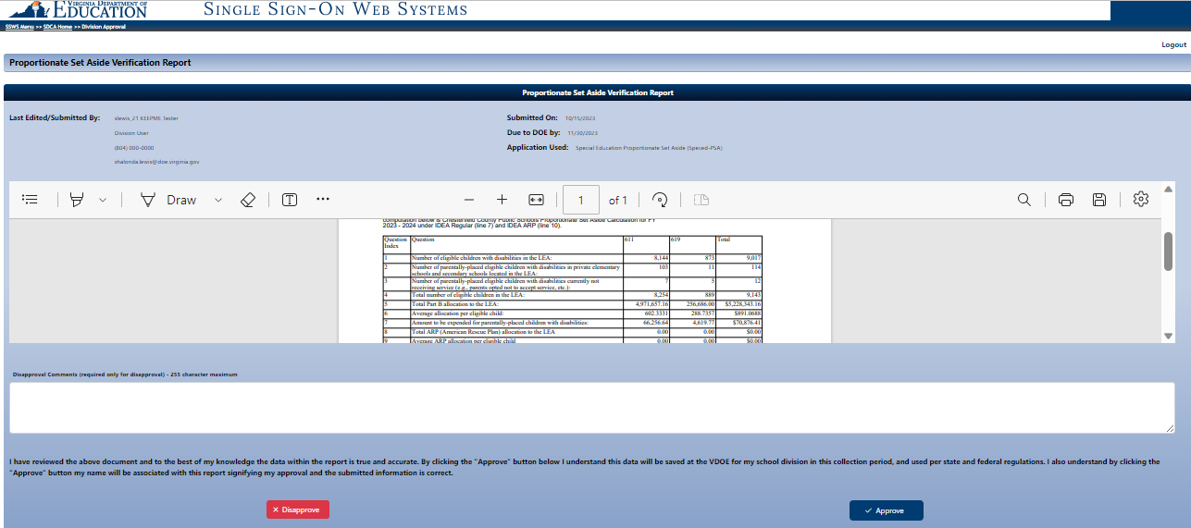

- Figure 12 displays the screen after the Approve button is clicked. The approval of the verification report represents the superintendent’s or designee’s electronic signature and indicates accuracy and completeness of the submitted data. If a revision is needed after the approval is completed, or if the superintendent did not electronically sign the verification report before the due date, the division must contact VDOE to reopen the collection window to complete submission.
Figure 12

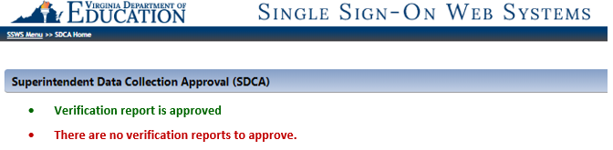

- Figure 13 displays the screen after the Disapprove button is clicked. All disapproved submissions require a data note in the comments box so the system can process the request. Once the disapproved submission is processed, the collection window will automatically reopen, and revisions are permitted. If the superintendent did not electronically sign the verification report before the due date, the division must contact VDOE to reopen the collection window to complete submission.
Figure 13
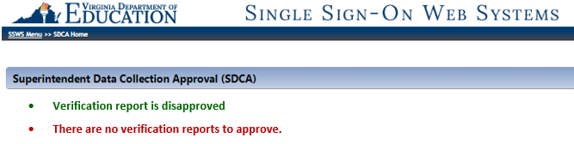

- Figure 14 displays the screen after the verification report is approved and completed. The online approval must be made within the established due date of the data collection for the submission to be considered complete. Verification reports that are certified after the collection window closes, after the due date (November 17, 2025), will be tagged as a late submission.
Figure 14
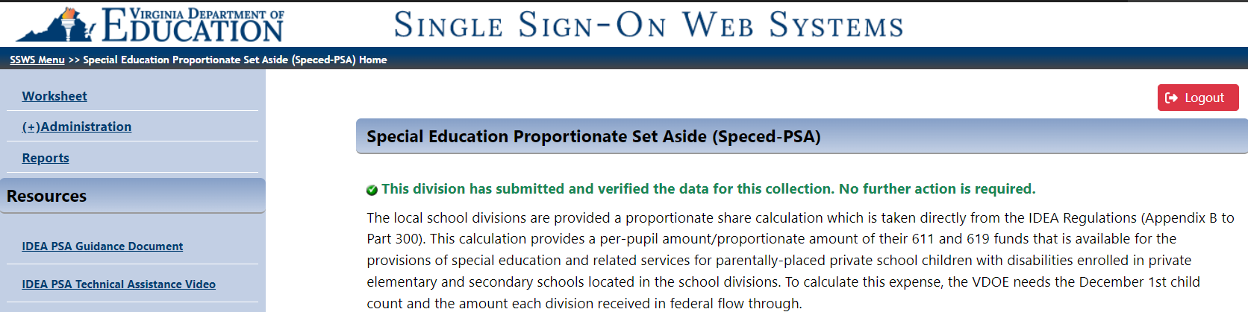

Please note the collection window will open on October 20, 2025, and close on November 17, 2025, at 11:59 p.m. Divisions not submitting the Speced-PSA calculation will be contacted individually and will be required to follow a protocol to reopen the collection window. This protocol will be shared with those specific school divisions. Late submissions and inaccurate reporting of information may impact the school division’s local determination matrix and may prompt an on-site fiscal monitoring review.

Important: Tracking PSA Budgets and Expenses for 2025-2026
Once the division has submitted the PSA data, school divisions will need to reserve PSA amounts under object codes “0000” in OMEGA until such time as the division is ready to use reserved PSA funds for PSA activities. Please provide a copy of the PSA Verification Report to people who are responsible for managing and tracking the PSA budgets. Remember that the set-aside amount must be calculated for both sections 611 and 619 funds. As a reminder, please do the following to enhance the tracking of PSA budgets and expenses:
- Submit a budget transfer (budget adjustment) in OMEGA for IDEA regular 611 or 619 funds to allocate all non-PSA budget amounts to applicable object code budgets (i.e., object codes 1000, 2000, 3000, 4000, 5000, 6000).
- Once PSA costs are incurred, please complete the following:
- Create the reimbursement request in Omega and select the PSA dropdown option, but do not submit it.
- Create the budget transfer (budget amendment) to move the amount of the PSA reimbursement to the appropriate object code(s) that coincide with your reimbursement. (The funds would move from 0000 to the object code(s) in the reimbursement.)
- Reference the reimbursement ID number in the budget transfer (budget adjustment). Then reference the budget transfer (budget adjustment) ID number in the reimbursement request.
- Submit the budget transfer. Prior to submitting the reimbursement request, please make sure the PSA dropdown option has been selected, then submit the reimbursement request for approval.

Important: One-Year Carryover Provision for 2025-2026
As a reminder, state and local funds may supplement and in no case supplant the proportionate amount of federal funds required to be expended for parentally-placed students with disabilities under this part. At the end of the carryover year (i.e., after June 30, 2026), if the PSA funds are not used, please provide an explanation and/or justification as to why these funds are no longer needed for PSA. Below are some examples of explanations. Each circumstance is unique; however, here are some examples of situations when the funds may be transferred to the public school for special education:
- The LEA no longer has any parentally placed nonpublic students with special needs within its jurisdiction.
- The LEA made a data error and never had any parentally-placed nonpublic students with special needs within its jurisdiction.
- The nonpublic school and LEA have consulted and determined that all of the needs of the students receiving special education services has not been met, but no additional funds can be expended.
- A home-schooled student with special needs refuses services.
- The students with special needs, in either a nonpublic school or a homeschool, have minimal needs, and expending the funds is impossible.

