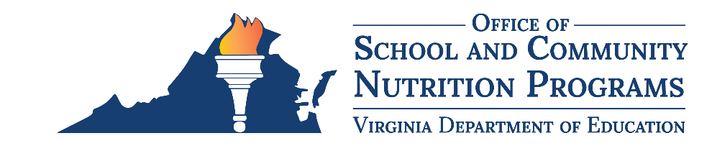
INSTRUCTIONS: This document is a sample. The local educational agency (LEA) is ultimately responsible for ensuring the plan complies with all federal and state regulations and the division’s Local School Wellness Policy. All content within the text boxes should be modified, as needed, according to each LEA’s unique exempt fundraiser practices. The VDOE-SCNP recommends allowing only non-food fundraisers or food and beverage fundraisers that meet the Smart Snacks rule. Additional pages may be added. The tracker must be kept on record as an electronic or paper copy.

Fundraiser Tracking Tool

School Name: Click or tap here to enter text.

School Year: Click or tap here to enter text.
According to the Healthy Hunger-Free Kids Act of 2010, all foods and beverages sold to students during the school day, including foods sold through school sponsored fundraisers, must meet the United States Department of Agriculture nutrition standards, also known as Smart Snacks in Schools. Virginia regulations in Virginia Code 8VAC20-740 permit up to 30 exempt fundraisers, per school, per school year. Click here to insert division name has elected to allow Click here to insert number of exempt fundraisers exempt fundraisers, per school, per school year. This tool tracks all food and beverage fundraisers approved by the fundraiser designee. Refer to the division’s Local School Wellness Policy for more information: Click or tap here to enter text.
Fundraiser Designee: Click or tap here to enter text.
Fundraiser Designee Contact Information: Click or tap here to enter text.
Organization Name¹ | Date² | Time(s)³ | Description of Items Sold | Smart Snacks Compliant? (y/n) | Location(s)⁴ | Organization’s Contact Name | Organization’s Contact Information | Fundraiser Designee’s Signature
¹ Name of school sponsored organization or activity.
² Date the fundraiser will be held. If the fundraiser spans multiple days, each date must be recorded as a separate fundraiser.
³ Foods or beverage fundraisers may not be held during school meal service times. This includes from 6:00 a.m. to the end of the breakfast period and from the beginning of the first lunch period to the end of the last lunch period.
⁴ Example: cafeteria, school store, snack bar, etc.

