Virginia’s Division Support Plan

Virginia’s Division Support Plan (DSP) integrates findings from Virginia’s needs assessment to help guide divisions as they prioritize work, predict and neutralize barriers, and catalyze transformative practices that will improve student outcomes. There are four sections to the Division Support Plan, aligned to the Virginia Support Framework:
- Academic Supports
- Staffing Supports
- Organizational Learning Supports
- School Climate Supports
High-quality improvement plans support division leaders as they work to allocate human and fiscal resources, establish short-and long-term goals, monitor processes, and scale successes. Specifically, a high-quality improvement plan is:
- grounded in the continuous improvement process and high expectations for all students;
- developed and revised through engagement with stakeholders-- including families; and,
- based on evidence-and research-based strategies aligned to the needs and context of the division.
Effective plans are based on the most important changes needed in the division and demonstrate alignment to federal, state, and division priorities by relating goals, objectives, measures, strategies, and resources to federal and state laws and guidance, including Virginia’s Support Framework.
How to use the Virginia Division Support Plan:
- Review the Virginia Support Framework domains and the results of the Virginia Support Framework Needs Assessment.
- Become familiar with the explanation and example of the Division Support Plan template which includes a description and example for each item.
- Complete the profile information with an overview of the internal and external stakeholder, including families, that have been engaged in the improvement process should also be documented.
- Use the results from the needs assessment to develop the plan for each domain and indicator, including the identifying barriers from root-cause analysis establishing division-level goals, selecting evidence-and research-based strategies, developing short-term objectives and quarterly measures to reach the Division-level goal, creating an action plan, and choosing artifacts to be regularly collected and analyzed for progress monitoring.

Domain of Support | Description of Domains
Academic | Schools and divisions acquire high-quality instructional materials, adopting instructional routines that are built around optimal instructional practices, and prioritizing placement of existing teachers, leaders and resources in the schools and classrooms that have the greatest need.
Staffing | School divisions ensuring that recruitment practices lead to hiring, placing, and retaining high-quality teachers and principals with critical expertise in the schools and classrooms most in need of support.
Organizational Learning | School divisions in identifying logistical and organizational practices that are necessary for creating an optimal learning environment.
School Climate | School divisions in building bridges between school and home, and removing barriers to learning and assuring greater school attendance and engagement.
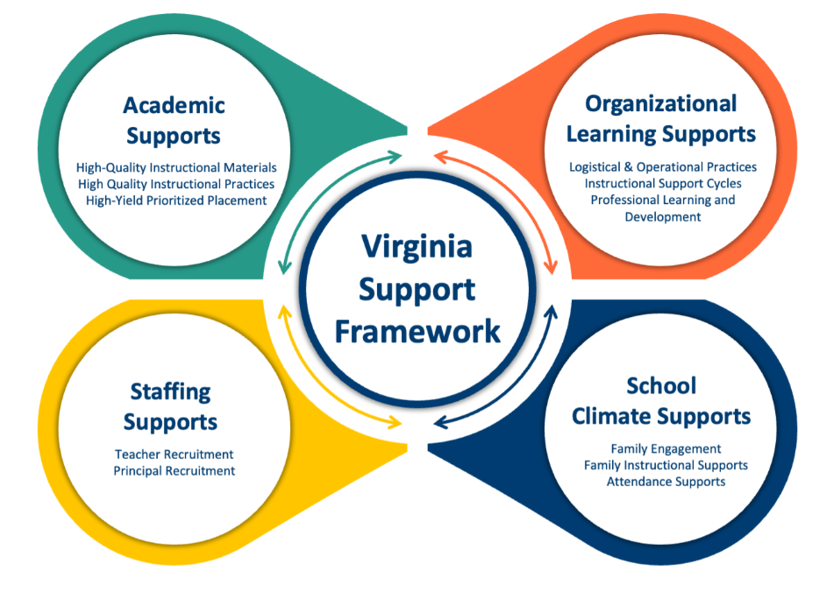
Profile Information
Division: Click or tap here to enter text. | Superintendent: Click or tap here to enter text.
Stakeholder/Family Engagement
Describe how the division will routinely involve internal and external stakeholders in the school improvement process to include conducting the needs assessment; selecting evidence-and research-based strategies; and developing, implementing, monitoring, and evaluating the plan. Click or tap here to enter text.

Domain I: Academic Supports |  |  | Focus Area: Choose an Item |  |  |  |  |  | ​ School Quality Indicator:
Division-level Goal:
Barrier(s):
Strategy:
Strategy:
Measurable Objective 1: |  |  |  |  |  | Measurable Objective 2:
Quarterly Progress Measures |  |  |  |  |  | Quarterly Progress Measures
Quarter 1 |  |  |  |  |  | Quarter 1
Quarter 2 |  |  |  |  |  | Quarter 2
Quarter 3 |  |  |  |  |  | Quarter 3
Quarter 4 |  |  |  |  |  | Quarter 4
Action Plan
OBJ: QTR | Action Steps  (Describe the step and include who will implement and how often it will be implemented) |  |  | Other Collaborators | Position/Office/ Department Responsible for Monitoring |  |  | Start of Action Step |  | End of Action Step | Budget (local, state, federal funds)
Select
Select
Select
Select
Select
Select
Select

Domain II: Staffing Supports |  |  |  | Focus Area: Choose an item.
Division-level Goal:
Barrier(s):
Strategy:
Strategy:
Measurable Objective 1: |  |  |  | Measurable Objective 2:
Quarterly Progress Measures |  |  |  | Quarterly Progress Measures
Quarter 1 |  |  |  | Quarter 1
Quarter 2 |  |  |  | Quarter 2
Quarter 3 |  |  |  | Quarter 3
Quarter 4 |  |  |  | Quarter 4
Action Plan
OBJ: QTR | Action Steps  (Describe the step and include who will implement and how often it will be implemented) |  | Other Collaborators | Position/Office/ Department Responsible for Monitoring |  | Start of Action Step | End of Action Step | Budget (local, state, federal funds)
Select
Select
Select
Select
Select
Select
Select

Domain III: Organizational Learning Support |  |  |  | Focus Area: Choose an item.
Division-level Goal:
Barrier(s):
Strategy:
Strategy:
Measurable Objective 1: |  |  |  |  | Measurable Objective 2:
Quarterly Progress Measures |  |  |  |  | Quarterly Progress Measures
Quarter 1 |  |  |  |  | Quarter 1
Quarter 2 |  |  |  |  | Quarter 2
Quarter 3 |  |  |  |  | Quarter 3
Quarter 4 |  |  |  |  | Quarter 4
Action Plan
OBJ: QTR | Action Steps  (Describe the step and include who will implement and how often it will be implemented) |  | Other Collaborators | Position/Office/ Department Responsible for Monitoring |  |  | Start of Action Step | End of Action Step | Budget (local, state, federal funds)
Select
Select
Select
Select
Select
Select
Select

Domain IV: School Climate Support |  |  |  | Focus Area: ​ Choose an Item
Division-level Goal:
Barrier(s):
Strategy:
Strategy:
Measurable Objective 1: |  |  |  |  | Measurable Objective 2:
Quarterly Progress Measures |  |  |  |  | Quarterly Progress Measures
Quarter 1 |  |  |  |  | Quarter 1
Quarter 2 |  |  |  |  | Quarter 2
Quarter 3 |  |  |  |  | Quarter 3
Quarter 4 |  |  |  |  | Quarter 4
Action Plan
OBJ: QTR | Action Steps  (Describe the step and include who will implement and how often it will be implemented) |  | Other Collaborators | Position/Office/ Department Responsible for Monitoring |  |  | Start of Action Step | End of Action Step | Budget (local, state, federal funds)
Select
Select
Select
Select
Select
Select
Select

