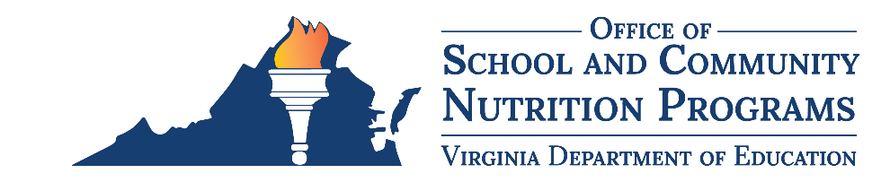

Federal Program Administrative Review School Nutrition Program Summary
Section 207 of the Healthy Hunger Free Kids Act 2010, amended section 22 of the National School Lunch Act (42 U.S.C. 1769c) requires the Virginia Department of Education, Office of School and Community Nutrition Programs (VDOE-SCNP), to report the final results of the administrative review to the public in an accessible, easily understood manner in accordance with guidelines promulgated by the Secretary.
School Food Authority (SFA): Park Place School SNP
Date of Administrative Review: May 7, 2024
Review Month and Year: February 2024
Date review results were provided to the SFA: May 8, 2024
Date review summary was publicly posted: July 19, 2024
SFA participates in the following Child Nutrition Programs:
☒ School Breakfast Program
☒ National School Lunch Program
☐ Fresh Fruit & Vegetable Program
☐ Afterschool Snack
☐ Seamless Summer Option
SFA operates under the following Special Provisions:
☐ Community Eligibility Provision
☐ Provision 2

Review Findings
Review Area | Details
Program Access and Reimbursement  ☒ Certification and Benefit Issuance  ☒ Verification  ☒ Meal Counting and Claiming | Incomplete applications were approved for meal benefits.  Applications were incorrectly approved for free and reduced-price meals.  Violations of verification procedures were found.  Verification activities were not completed by the deadline.  Daily edit checks for meals served were not completed.  Monthly claim consolidation errors were discovered.
Meal Patterns and Nutritional Quality  ☒ Meal Components and Quantities  ☐ Offer versus Serve  ☐ Dietary Specifications and Nutrient Analysis | Meal pattern crediting documentation was not available for items served.  Daily minimum requirement for grains, vegetables, and fruit were not met.  The weekly minimum requirements for vegetables and fruit were not met.  Grains served were not whole grain rich.  Milk variety violations were observed.
School Nutrition Environment and Civil Rights  ☒ Food Safety  ☒ Buy American  ☒ Local Wellness Policy  ☐ Smart Snacks and Competitive Foods  ☒ Civil Rights | Violations of the Buy American provision were observed.  Food safety inspections were not completed or requested.  Temperature logs were not maintained.  The local wellness policy did not contain all required elements.  Nondiscrimination statement was missing from program materials.
This institution is an equal opportunity provider.

