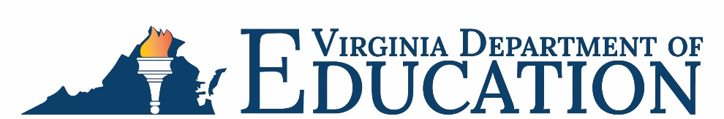

Office of School Nutrition Programs

Federal Program Administrative Review School Nutrition Program Summary
Section 207 of the Healthy Hunger Free Kids Act 2010, amended section 22 of the National School Lunch Act (42 U.S.C. 1769c) requires the Virginia Department of Education, Office of School Nutrition Programs (VDOE-SNP), to report the final results of the administrative review to the public in an accessible, easily understood manner in accordance with guidelines promulgated by the Secretary.
School Food Authority (SFA): Madison County Public Schools
Date of Administrative Review: March 7 – 9, 2023
Review Month and Year: January 2023
Date review results were provided to the SFA: March 16, 2023
Date review summary was publicly posted: June 2, 2023
SFA participates in the following Child Nutrition Programs:
☒ School Breakfast Program
☒ National School Lunch Program
☐ Fresh Fruit & Vegetable Program
☐ Afterschool Snack
☒ Seamless Summer Option
SFA operates under the following Special Provisions:
☒ Community Eligibility Provision
☐ Provision 2

Review Findings
Review Area | Details
Program Access and Reimbursement  ☐ Certification and Benefit Issuance  ☐ Verification  ☐ Meal Counting and Claiming | No findings identified.
Meal Patterns and Nutritional Quality  ☐ Meal Components and Quantities  ☐ Offer versus Serve  ☐ Dietary Specifications and Nutrient Analysis | No findings identified.
School Nutrition Environment and Civil Rights  ☒ Food Safety  ☒ Local Wellness Policy  ☐ Smart Snacks and Competitive Foods  ☐ Civil Rights | The food safety plan did not contain all required components.  The Local Wellness Policy did not contain all required components.
USDA is an equal opportunity provider, employer, and lender.

